Assignment: Create a CloudWatch billing alarm which goes off when the estimated
charges go above $500.
Step1: Open AWS console > Search Billing and cost management.
Step2: Under Preferences and Settings > Alerts Preference > Enable CloudWatch billing alerts.
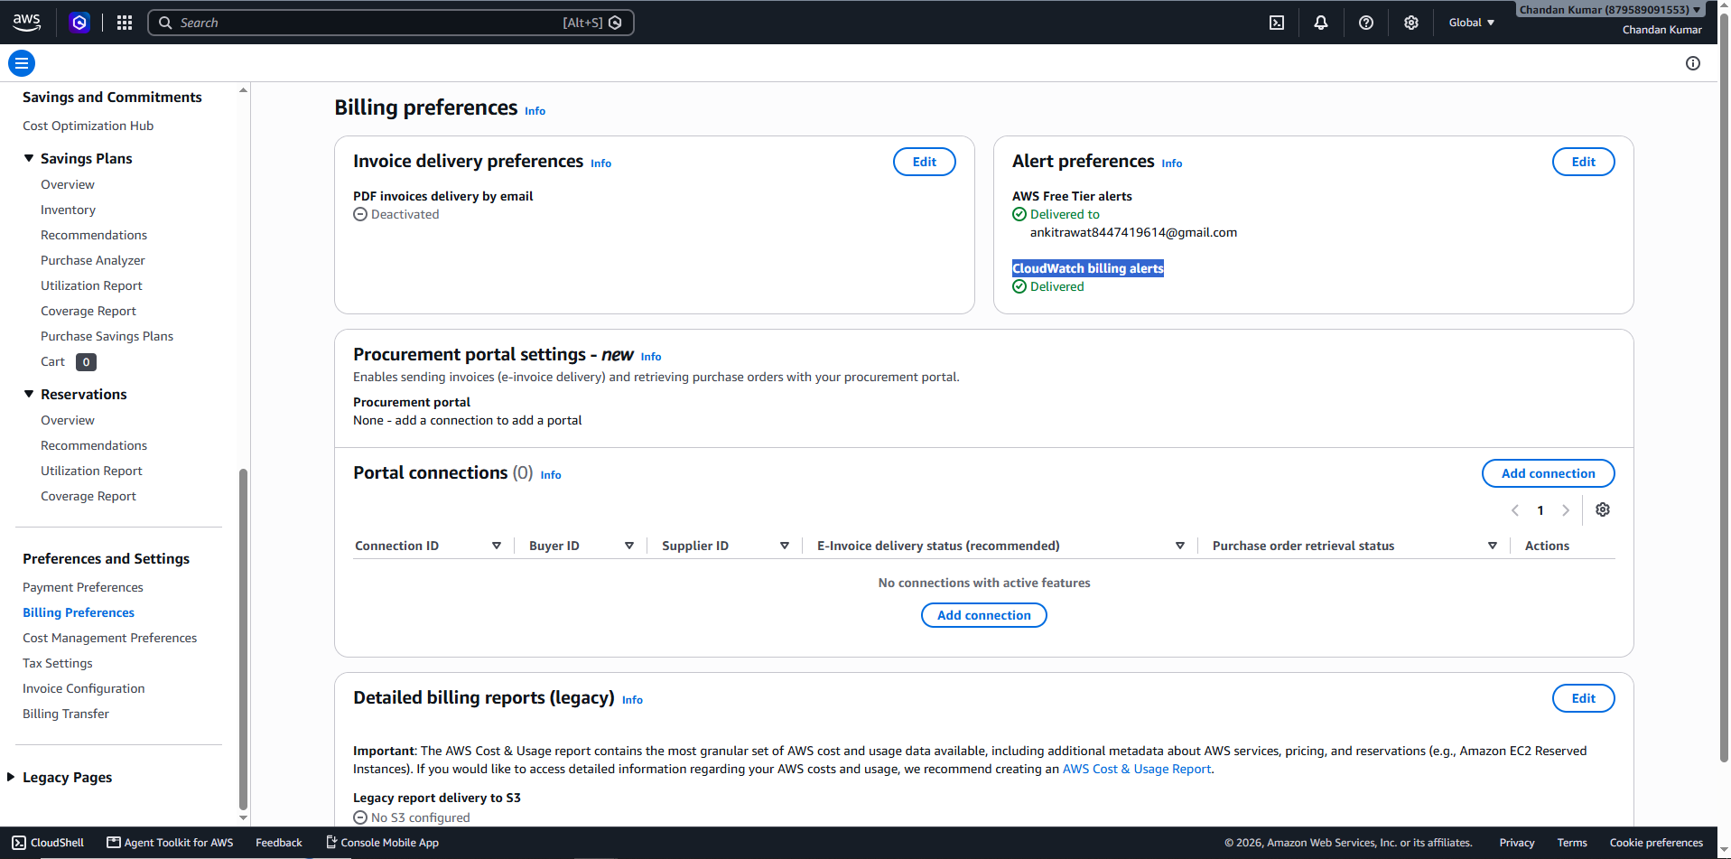
Step 3: Search CloudWatch and open it.
Step 4: Under CloudWatch > Go to Alarms > Click on Create Alarms
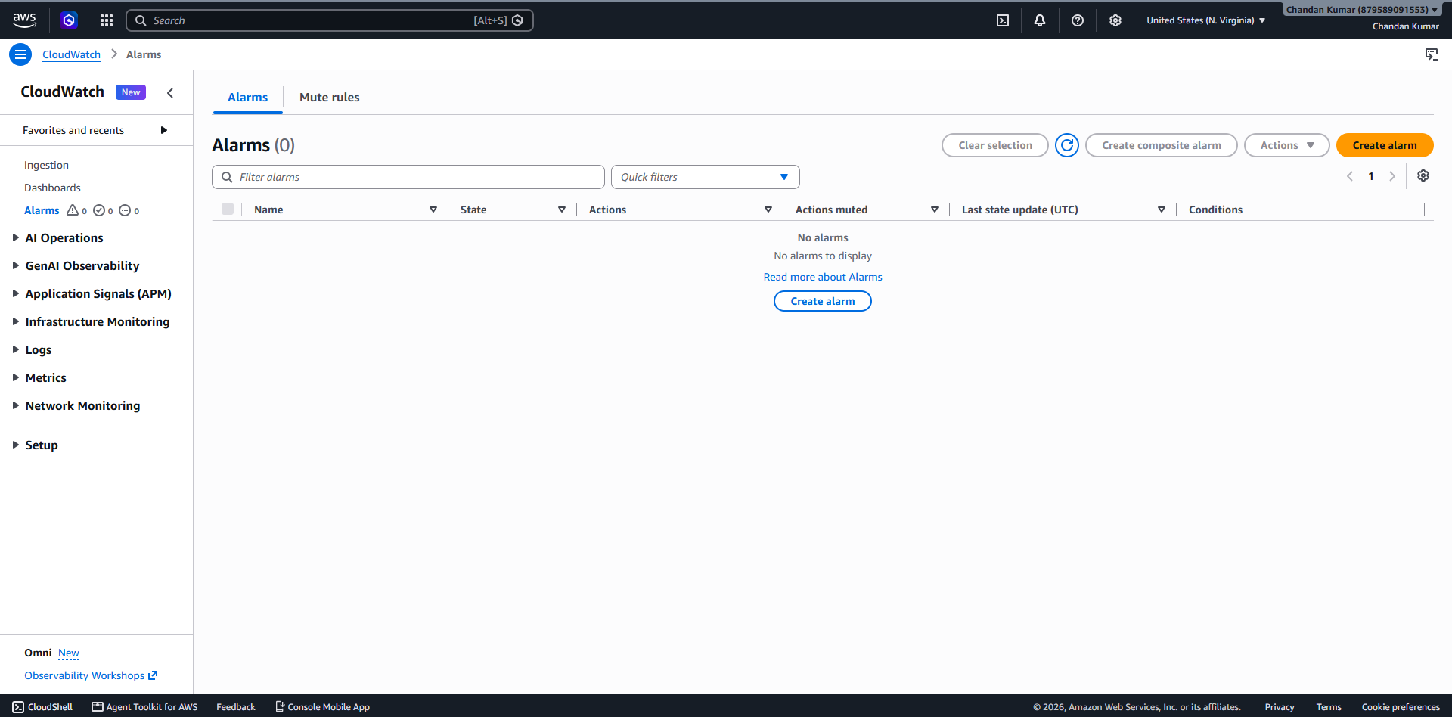
Step 5: Under Specify metric and conditions > Data source = Metrics > Type = Classic > Click on select Metric > Select Total Estimated Charges > Click on select Metric.
Step 6: Under conditions > Threshold type = Static > Whenever Estimated Charges is... = Greater /Equal > than = 500 USD > Click on Next.
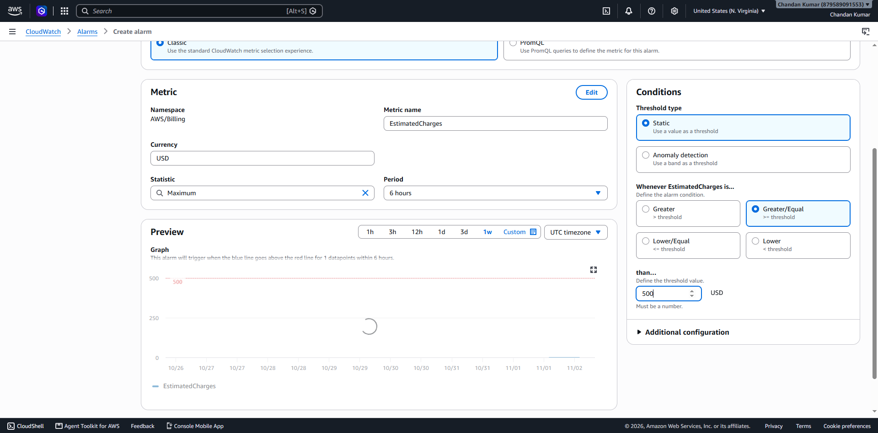
Step 7: Under Configure actions > Alarm state trigger = In Alarm > Send a notification to the following SNS topic = Create new Topic > Create a new topic… = CloudWatch_Alarms_BillingExceeds > Email endpoints that will receive the notification… = ankitrawat8447419614@gmail.com > Click on create topic . > A notification is sent to the registered email from where we have to allow subscription there.
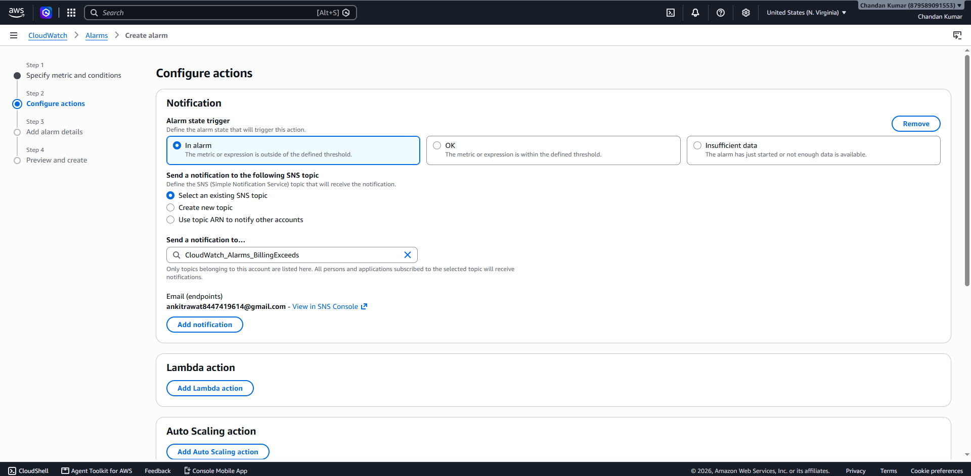
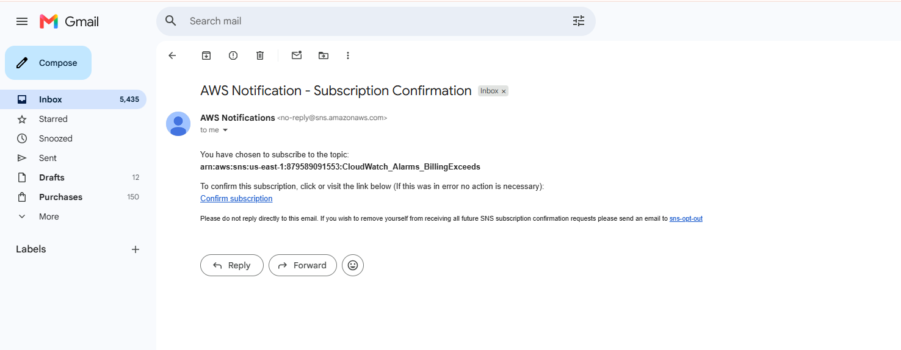
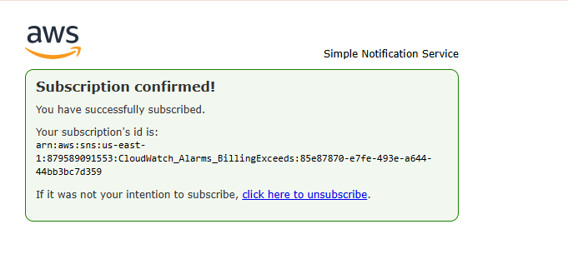
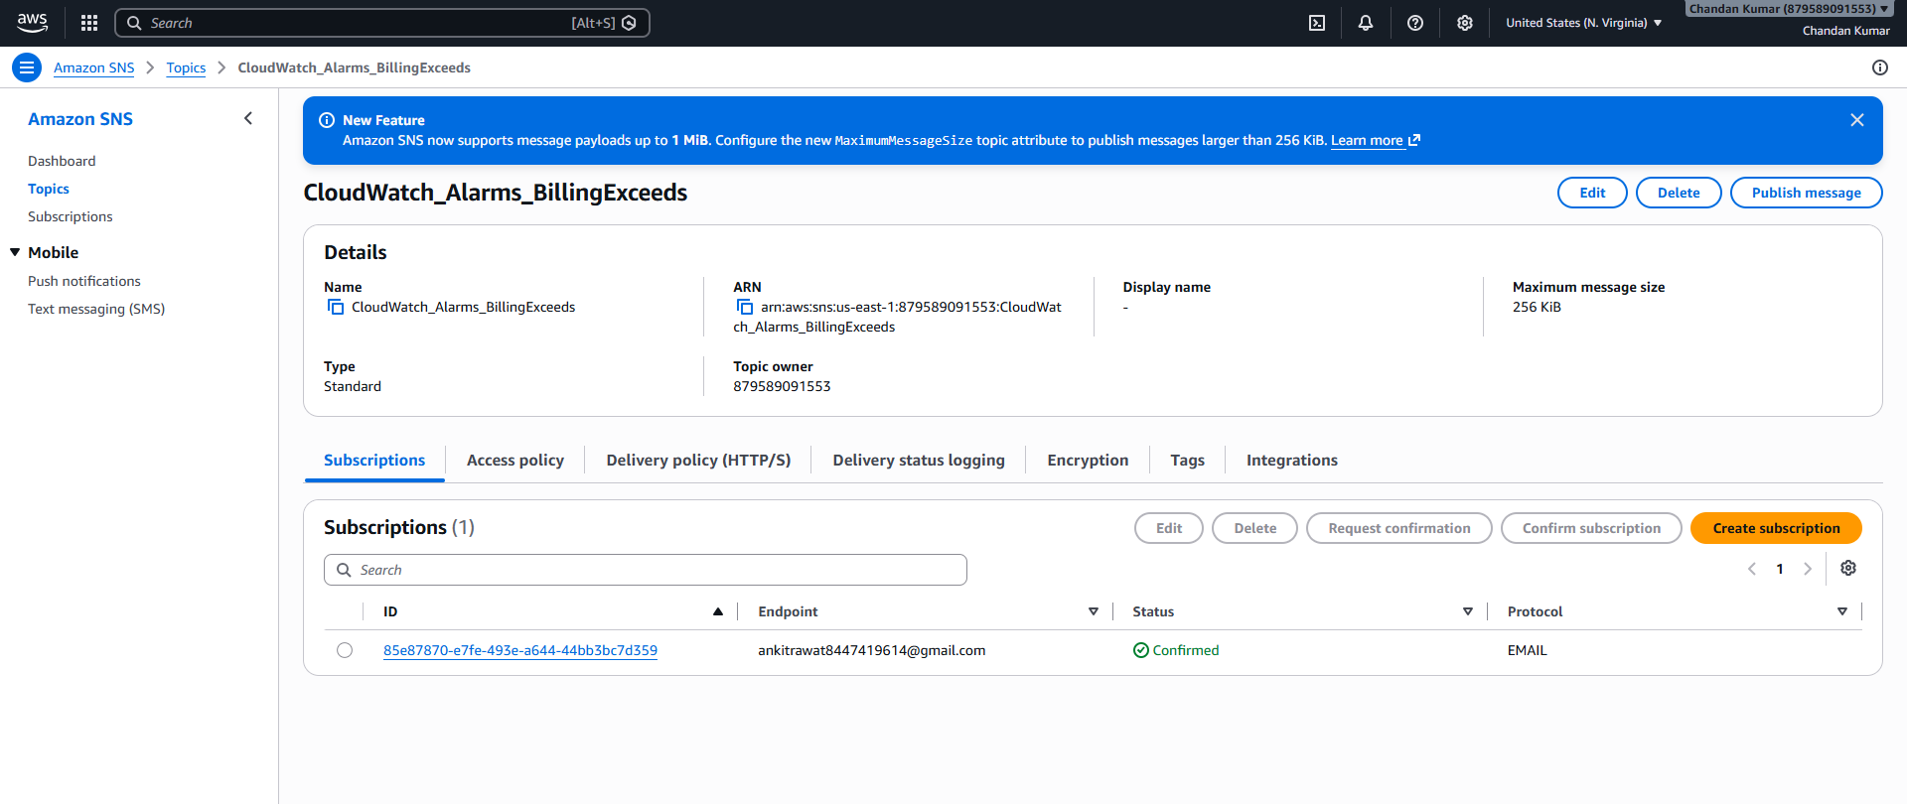
Step 8: Enter Alarm Name: Billing Alarm more than $500 > in edit fill message > Click on next.
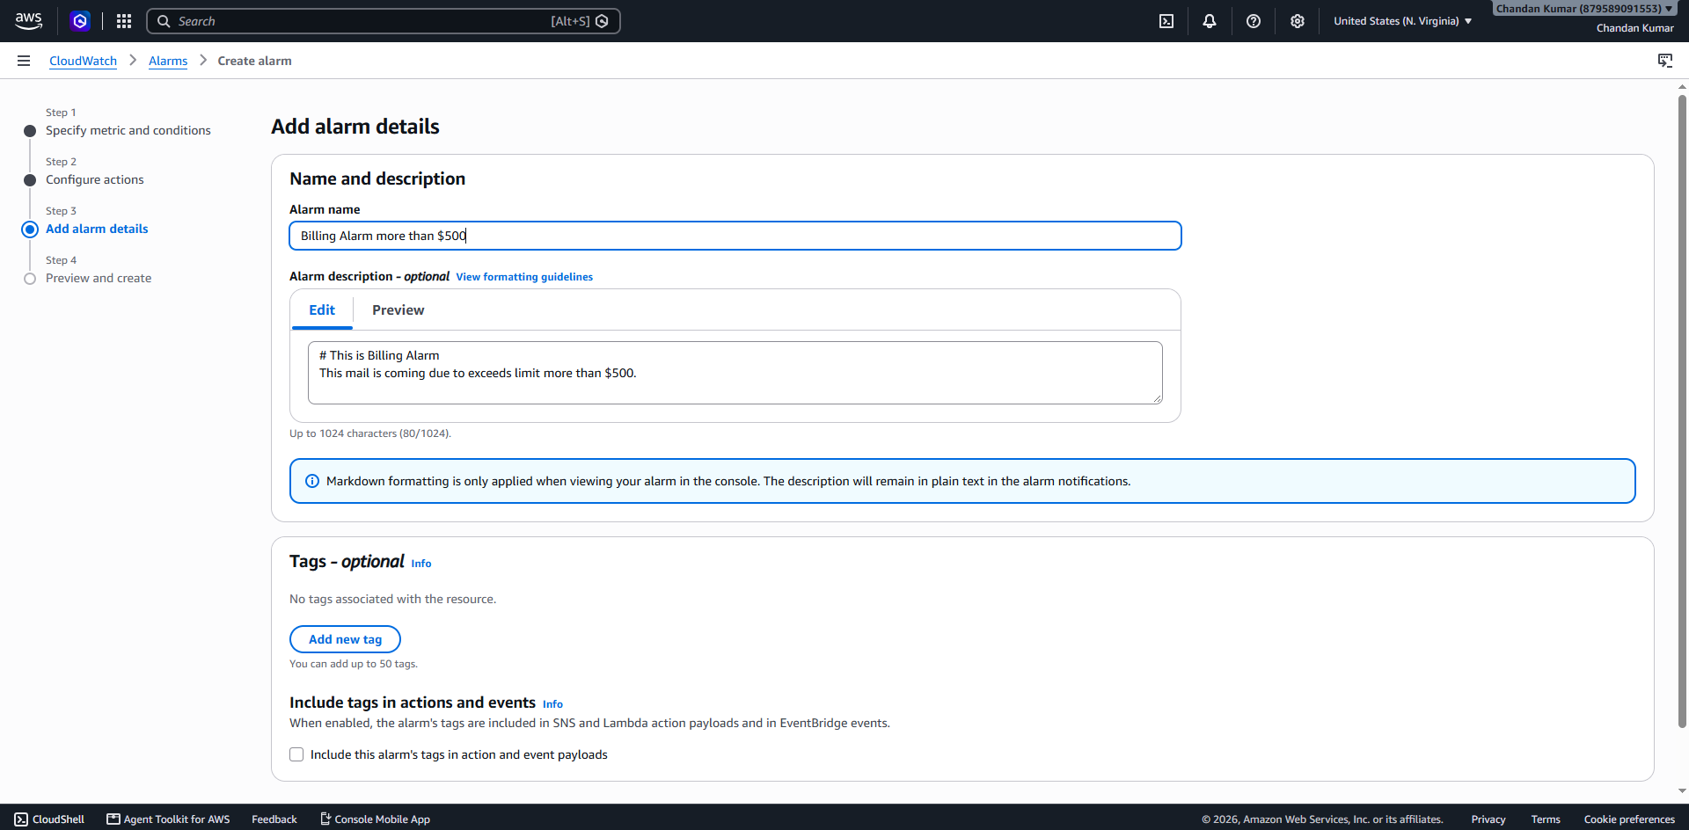
Step 9: Click on create Alarm.


